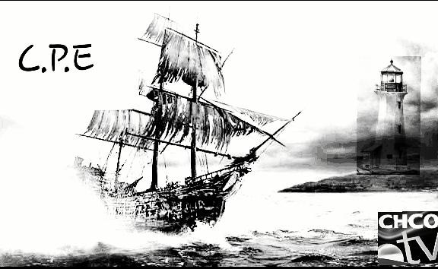

Waiver for Canadian paranormal expeditions and the team to

Do a paranormal investigation. Permission period valid from dates; day______month_____year_____.

I ____________________ by signing this waiver I agree to release Canadian paranormal expeditions from any or all liability for personal injuries.

Name: ______________________________ (printed)

Address: ____________________________

Email: ______________________________

Phone: _____________________________ (optional)

Signature: ___________________________

Conditions:

1. To respect the rights of the property owner.
2. To be careful.
3. Not to damage building or property.
4. No littering or dumping rubbish while on property.
5. To obey rules and regulations.
6. This free permit is only valid on the land of the issuing date only.